CHAPTER FOUR
FINDINGS AND ANALYSIS
4.1 Introduction
This chapter presents the quantitative findings generated from two complementary survey datasets collected in Hathazari Upazila. The first dataset captures citizens’ service-use experiences (N = 102) and provides the primary evidence for the study’s core relationships—specifically, how perceived e-service quality relates to administrative burden and, in turn, to overall citizen satisfaction. The second dataset draws on officials’ responses (N = 13) and is used as a supply-side lens to validate and interpret the citizen results, particularly around operational capacity, process simplification, and administrative efficiency.
In practical terms, the citizens’ survey is treated as the main conceptual base for testing the direction and strength of the pathways (E-service Quality → Administrative Burden → Citizen Satisfaction), while the officials’ survey adds contextual depth on what is feasible in day-to-day implementation and where bottlenecks remain. The chapter is structured as follows: Section 4.2 explains the quantitative analysis approach; Section 4.3 profiles citizens and officials; Sections 4.4–4.6 report findings on e-service quality, administrative burden, and satisfaction; and Section 4.7 synthesizes results around administrative efficiency and overall impact.
4.2 Quantitative Analysis of Survey Data
4.2.1 Data sources and sample sizes
Two primary datasets were used in this chapter. The citizen survey includes 102 respondents who reported recent experiences with local government e-services in Hathazari Upazila. The officials’ survey includes 13 service providers/administrators working at Upazila and Union levels. Who reported on operational conditions, citizen-facing challenges, and efficiency effects of e-services.
4.2.2 Measurement and coding
All closed-ended survey items were coded on a 5-point Likert scale (1 = lowest agreement/most negative perception; 5 = highest agreement/most positive perception), with reverse-coding applied where needed to ensure consistent directionality of indices. In particular, items phrased positively in relation to reduced burden were reverse-coded so that higher values uniformly indicate higher administrative burden for the burden indices.
Constructs were operationalized through composite indices based on relevant item sets: (i) e-service quality (citizen dataset), (ii) administrative burden, measured through learning, compliance, and psychological cost dimensions (citizen dataset), (iii) citizen satisfaction (citizen dataset), and (iv) administrative efficiency indicators drawn from both datasets where conceptually comparable items existed.
4.2.3 Analytical techniques
The analysis proceeded in four steps. First, descriptive statistics (frequencies, means, and standard deviations) were used to summarize respondent characteristics and item responses. Second, internal consistency for multi-item indices was assessed using Cronbach’s alpha. Third, bivariate association patterns were examined using correlation analysis. Finally, regression modelling was used to test the hypothesized relationships among e-service quality, administrative burden, and citizen satisfaction, including mediation testing where applicable. Given the small officials’ sample size, officials’ quantitative results are reported primarily through descriptive distributions and role/context profiling rather than inferential modelling.
4.2.4 Missing data and assumptions
Across the datasets, missingness is concentrated in open-ended questions, which is typical in mixed-format surveys. The core Likert-scale blocks used for index construction and quantitative modelling are largely complete, supporting stable estimation of descriptive and regression results. Where minor non-response occurs, analyses are based on available cases for the relevant items.
4.3 Demographic Characteristics of the Study Participants
4.3.1 Citizens’ demographic profile
Table 4.1 summarizes the socio-demographic profile of citizen respondents (N = 102) and their self-reported frequency of using government e-services in the past six months. Overall, the sample is dominated by younger service users and comparatively higher educational attainment, which is consistent with the expectation that digitally mediated services are more frequently used by groups with greater digital exposure. This profile should be kept in view when interpreting the results, particularly in relation to learning costs and perceived ease of use.
Table 4.1: Demographic Profile of Citizen Respondents (N = 102)
Variable | Category | n | %
Age group | A. 18–25 | 49 | 48.0
 | B. 26–35 | 31 | 30.4
 | C. 36–45 | 15 | 14.7
 | D. 46–60 | 7 | 6.9
Gender | B. Female | 57 | 55.9
 | A. Male | 45 | 44.1
Education | B. Bachelor’s Degree | 38 | 37.3
 | C. Master’s Degree | 37 | 36.3
 | A. High School | 15 | 14.7
 | College | 12 | 11.8
Occupation | Student | 53 | 52.0
 | Business owner/Self-employed | 19 | 18.6
 | Homemaker | 13 | 12.7
 | Government employee | 7 | 6.9
 | Private sector employee | 6 | 5.9
 | Unemployed | 2 | 2.0
 | Other | 2 | 2.0
E-service use (past 6 months) | B. Rarely | 34 | 33.3
 | C. Sometimes | 29 | 28.4
 | A. Never | 25 | 24.5
 | D. Often | 12 | 11.8
 | E. Always | 2 | 2.0
Note: Percentages are calculated within the citizen sample (N = 102) and may not sum to exactly 100% due to rounding.
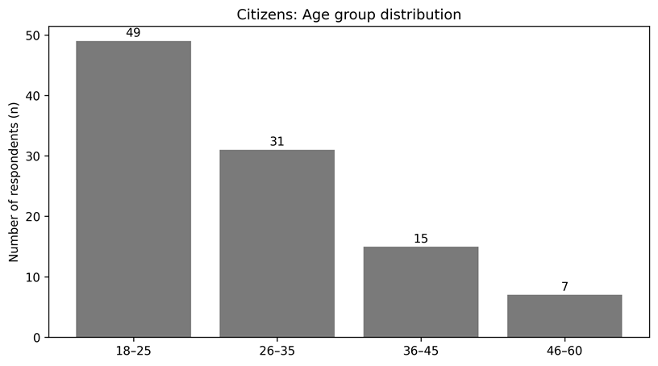
Figure 1. Citizens: Age group distribution (n shown).

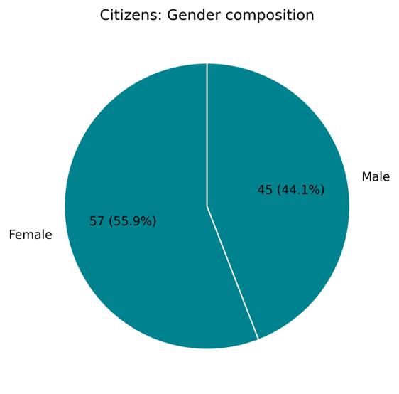
Figure 2. Citizens: Gender composition (n and % shown).

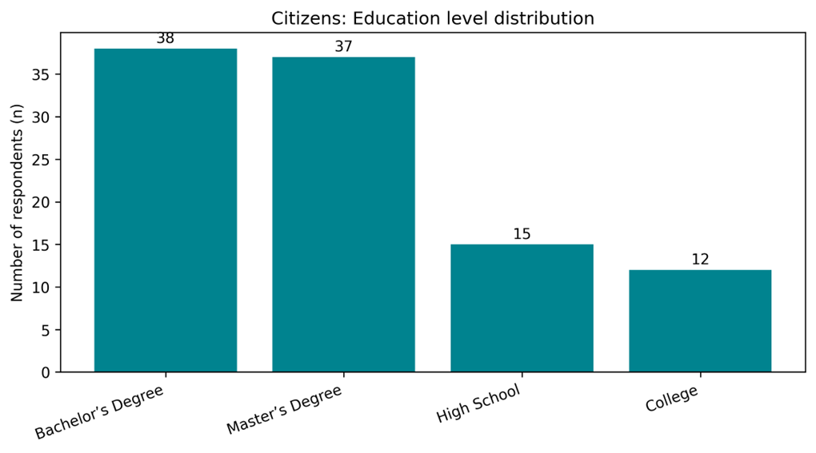
Figure 3. Citizens: Education level distribution (n shown).

Figure 4. Citizens: Occupation distribution (n shown).
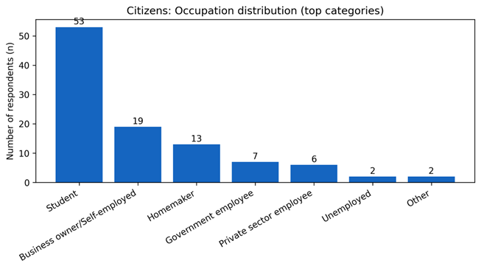
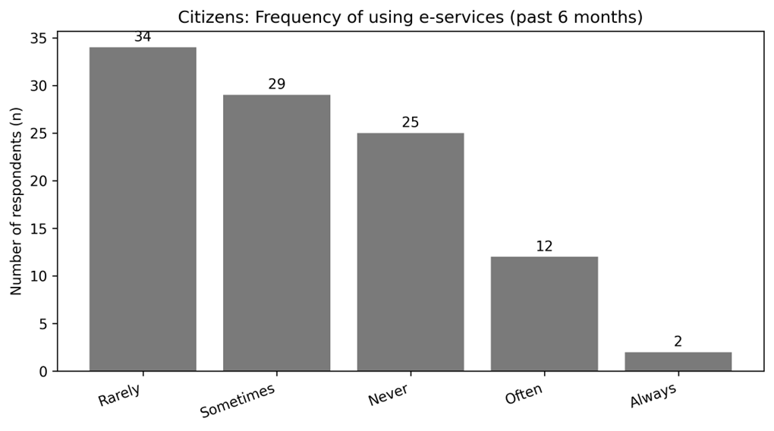
Figure 5. Citizens: E-service use frequency (n shown).

4.3.2 Officials’ role and service context profile
To complement the citizen results, Table 4.2 profiles the officials who participated in the provider-side survey (N = 13). This distribution clarifies whose operational experiences are reflected in the supply-side evidence—particularly institutional level, years of service, training exposure, and estimated weekly service load. These characteristics are important for triangulation: officials with longer service experience and higher weekly workloads are positioned to comment credibly on whether e-services are simplifying processes in practice, and whether citizen-facing burden points are diminishing or merely shifting in form.

Table 4.2: Officials’ Professional Profile and Service Context (N = 13)
Profile dimension | Category | n | %
Role/designation | B.Secretary | 7 | 53.8
 | Other | 2 | 15.4
 | C. Administrative Officials | 2 | 15.4
 | UDC Entrepreneur | 2 | 15.4
Institution level | B. Union | 10 | 76.9
 | A. Upazila | 3 | 23.1
Years of service | E. 21+ years | 5 | 38.5
 | C. 7-15 years | 4 | 30.8
 | D. 16-20 years | 3 | 23.1
 | B. 1-6 years | 1 | 7.7
ICT/e-service training | A. Yes | 9 | 69.2
 | B. No | 4 | 30.8
Requests handled per week | 26–50 | 5 | 38.5
 | 11–25 | 4 | 30.8
 | 51+ | 2 | 15.4
 | Varies/Not specified | 2 | 15.4
Note: Officials also reported handling multiple service types. The most frequently mentioned e-services were: Birth certificate (n=9); Death certificate (n=6); Testimonial/Citizenship/Character certificate (n=5); e-Nothi (n=2); Correction services (n=1); Job information (n=1); Social safety net/Disability benefits (n=1). Because officials could list up to three services, counts in this note represent mentions rather than mutually exclusive categories.

Figure 6. Officials: Role/designation (n shown).
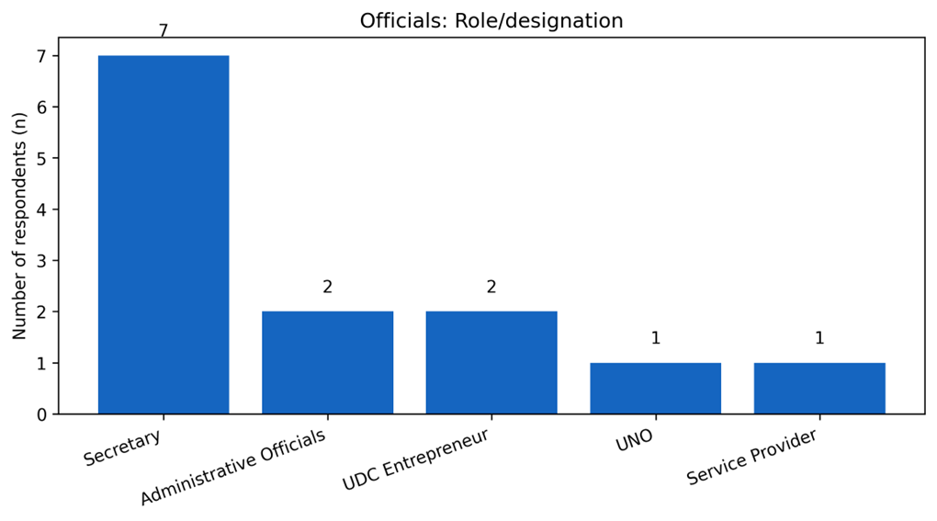

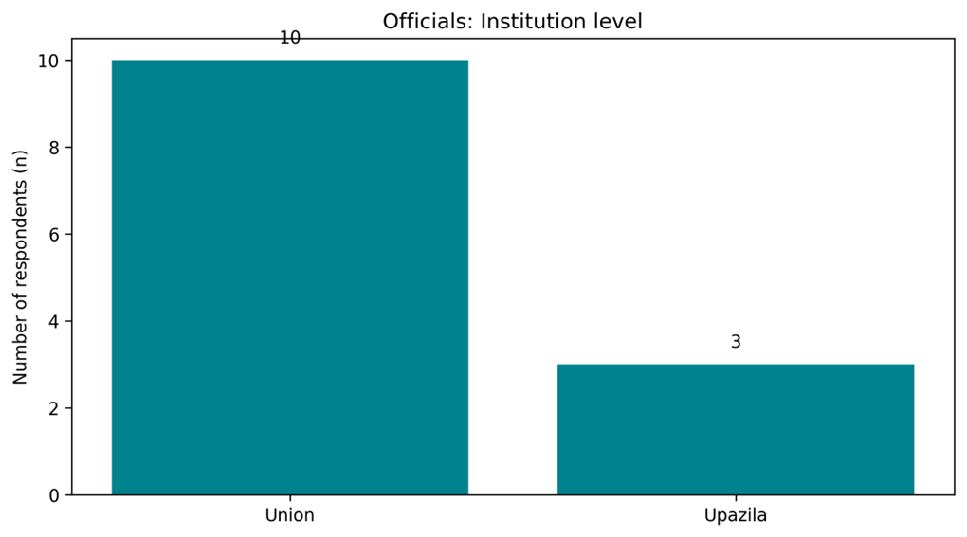
Figure 7. Officials: Institution level (n shown).
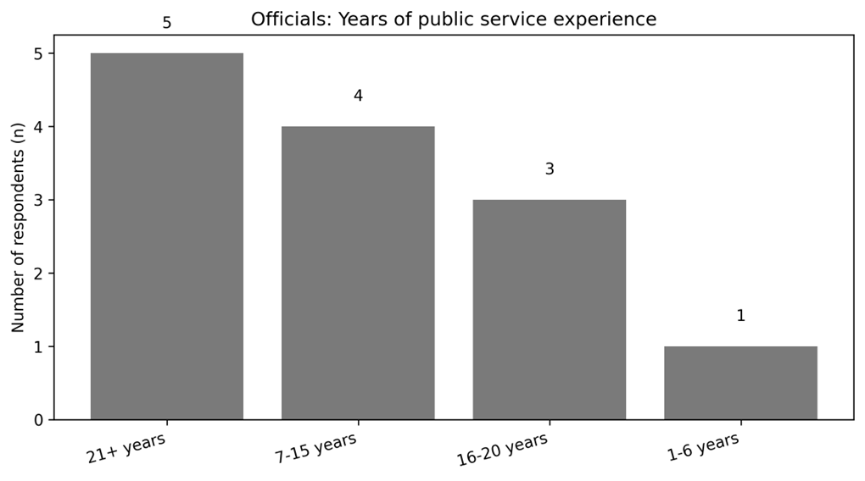
Figure 8. Officials: Years of experience

4.4 E-service Quality and System Performance
4.4.1 Citizens’ assessment of e-service quality
This subsection reports citizens’ perceptions of e-service quality as captured through five service-experience items covering accessibility/uptime, service findability, clarity of instructions/forms, transparency of document/fee information, and perceived data security. Responses were coded on a five-point scale (1 = strongly disagree to 5 = strongly agree). Table 4.3 presents item-level descriptive statistics, followed by the composite e-service quality index in Table 4.4.
Table 4.3: E-service Quality Items (Citizens, N = 102)
Dimension | Mean | SD | N
Accessibility/uptime | 3.43 | 0.75 | 102
Findability | 3.29 | 0.89 | 102
Clarity of instructions/forms | 3.56 | 0.78 | 102
Transparency of fees/docs | 3.59 | 0.85 | 102
Perceived data security | 3.31 | 0.89 | 102
Note: Higher mean values indicate more positive perceptions of the e-service experience.
Overall, citizens reported a moderately positive assessment of e-service quality. The strongest dimension was Transparency of fees/docs (M = 3.59, SD = 0.85), closely followed by Clarity of instructions/forms. By contrast, the weakest dimension was Findability (M = 3.29, SD = 0.89). Substantively, this pattern suggests that respondents were relatively more confident about the clarity and transparency of information provided on the portal, while they were less consistently positive about quickly locating services and, to a lesser extent, about data security.
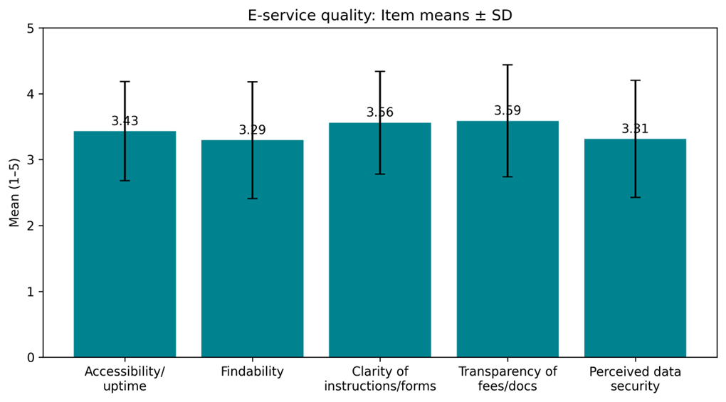
Figure 9. E-service quality items: Means ± SD.

Table 4.4: E-service Quality Index (Citizens)
Index | Mean | SD | N
E-service Quality Index (mean of 5 items) | 3.44 | 0.62 | 102
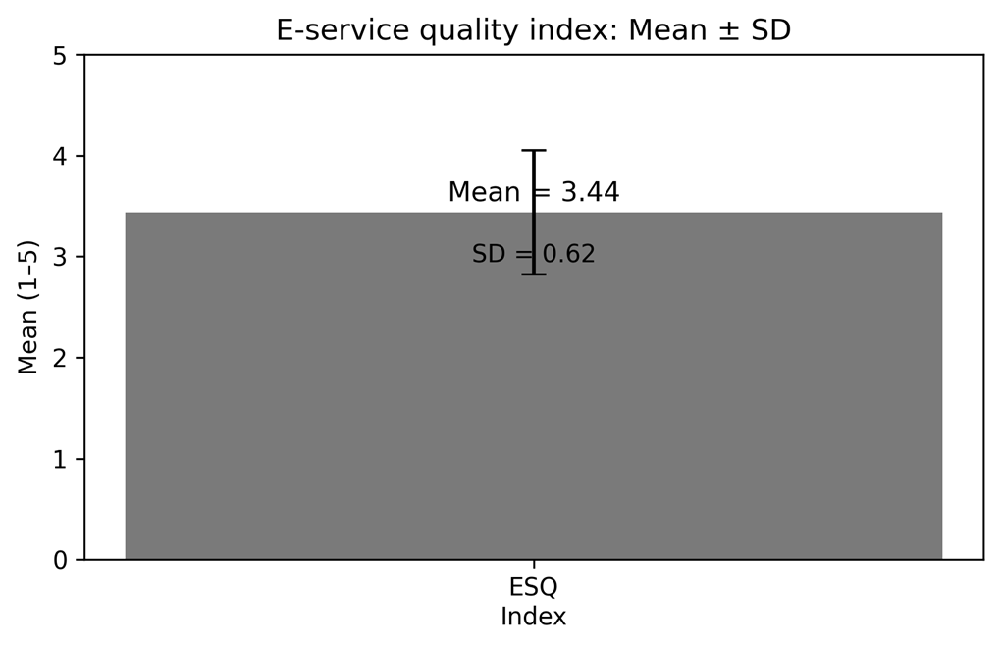
As shown in Table 4.4, the overall e-service quality index averaged 3.44 (SD = 0.62) on a 5-point scale, indicating that the typical respondent leaned slightly above the neutral midpoint in evaluating system performance. In the discussion chapter, this overall pattern is interpreted alongside administrative burden outcomes, because service quality and burden reduction are expected to move together in digital service settings.
Figure 10. E-service quality index:
Mean ± SD.

4.4.2 Officials’ assessment of system performance
To triangulate citizen perceptions, the officials’ survey captured provider-side assessments of system readiness and performance conditions. Given the smaller provider sample (N = 13), the results are presented descriptively, focusing on core operational enablers: availability of ICT equipment, reliability of internet connectivity, staff ICT competence, and perceived process simplification through reduced manual steps.

Table 4.5: Officials’ Assessment of System Performance (N = 13)
Indicator | Mean | SD | N
ICT equipment adequacy | 3.31 | 0.85 | 13
Internet reliability | 2.85 | 0.99 | 13
Staff ICT competence | 3.31 | 0.85 | 13
Process simplification (fewer manual steps) | 4.08 | 0.28 | 13
Note: Officials’ responses were coded to align with the five-point agreement scale where applicable. In two items, response categories were recorded as Agree/Neutral/Disagree; these were mapped to 4/3/2 respectively to retain scale interpretability.
A clear convergence emerges between the two datasets on the practical logic of e-services. Officials strongly endorsed the claim that e-services reduce manual steps (M = 4.08), which aligns with citizens’ generally positive ratings on clarity and transparency of the online process. At the same time, the provider-side profile points to operational constraints that plausibly explain why citizen ratings are not uniformly high across all quality dimensions. Internet reliability has the lowest official mean (M = 2.85), suggesting that service continuity and speed remain dependent on infrastructure stability. Officials’ assessments of ICT equipment adequacy (M = 3.31) and staff ICT competence (M = 3.31) were moderate, indicating functional capacity but with room for strengthening—particularly if the objective is to reduce citizens’ dependence on repeated support and to deliver a consistently smooth user experience.

4.5 Administrative Burden
This section examines administrative burden as experienced by citizens when using local government e-services in Hathazari Upazila. Consistent with the study’s framework, burden is reported through three dimensions—learning costs, compliance costs, and psychological costs. The citizen survey provides the primary evidence, while the officials’ survey is used to clarify why certain burden points persist in practice, particularly where implementation constraints (skills, verification rules, or system conditions) limit the burden-reducing potential of digital channels.
4.5.1 Learning Costs (Time/Effort to Understand the Process)
Learning costs capture the time and effort required to understand how to use the e-service platform and complete the process. On the composite learning-cost index (higher scores indicate higher burden), citizens reported a mean of 2.56 (SD = 0.63). Table 4.6 reports item-level indicators.
Table 4.6: Learning Cost Indicators (Citizens, N = 102)
Indicator | Mean | SD | N
Spent a lot of time learning how to use the e-service system (Q7) | 2.90 | 0.96 | 102
Online system requires less effort than visiting office (reverse-coded) (Q8R) | 1.85 | 0.81 | 102
Needed to call/visit office because website was unclear (Q9) | 2.92 | 0.98 | 102

From an operational standpoint, officials’ responses reinforce that learning-related challenges remain salient for a portion of service users—particularly regarding digital skills and the need for assistance. Table 4.7 summarizes provider-side perceptions of these learning barriers.
Figure 11. Learning cost indicators (citizens): Means ± SD.
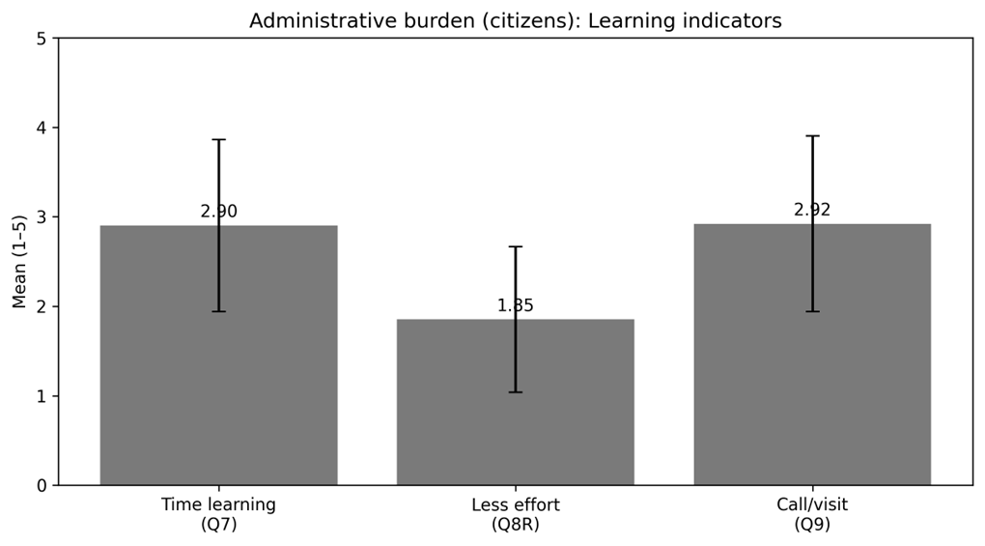
Table 4.7: Officials’ Perception of Learning Challenges (N = 13)
Indicator | Mean | SD | N
Citizens struggle to understand steps without assistance (Item 5) | 2.77 | 0.83 | 13
Citizens lack digital skills to use e-services independently (Item 6) | 3.69 | 0.48 | 13
Citizens require repeated explanation of requirements/procedures (Item 7) | 3.00 | 0.58 | 13
4.5.2 Compliance Costs (Time/Resources to Meet Requirements)
Compliance costs refer to the time, documentation, and resources required to meet procedural requirements, including waiting time and extra expenditures beyond official fees. Even in a digital process, citizens reported a mean compliance-cost index of 3.22 (SD = 0.63), suggesting that compliance burdens are still moderate to severe. Table 4.8 presents the item-level indicators.
Table 4.8: Compliance Cost Indicators (Citizens, N = 102)
Indicator | Mean | SD | N
Could upload/submit required documents without issues (reverse-coded) (Q12R) | 2.80 | 0.91 | 102
Spent a lot of time waiting (online or in-person) (Q13) | 3.30 | 0.89 | 102
Had extra costs beyond official fee (Q14) | 3.26 | 0.97 | 102
Had to submit many documents/requirements (Q15) | 3.49 | 0.91 | 102
Officials’ responses point to a key structural reason for persistent compliance burden: even when services are started online, completion often still involves multiple contacts or visits—typically related to verification, document checking, or follow-up requirements. Table 4.9 reports the provider-side indicator of this bottleneck.

Figure 12. Compliance cost indicators (citizens): Means ± SD.

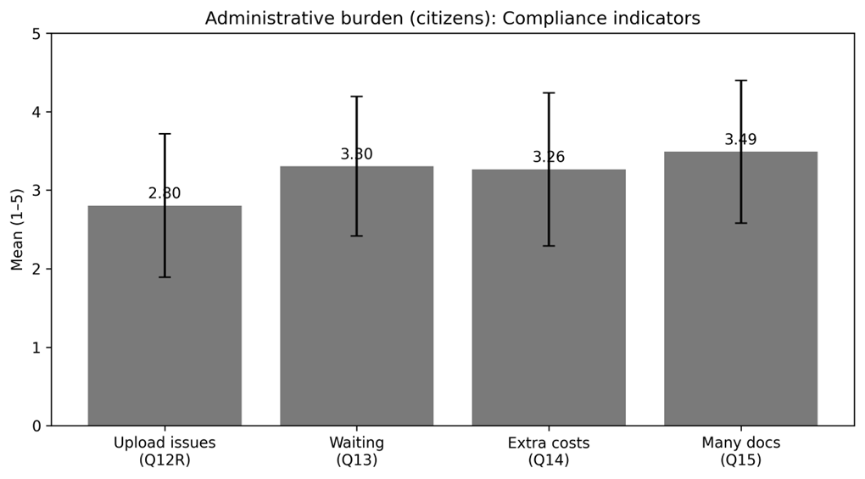
Table 4.9: Officials’ View of Compliance/Process Bottlenecks (N = 13)
Indicator | Mean | SD | N
Even with e-service, citizens still need multiple visits/contacts (Item 8) | 4.15 | 0.38 | 13

4.5.3 Psychological Costs (Stress/Frustration)
Psychological costs reflect anxiety, uncertainty, and frustration experienced during the e-service process, including fear of errors, system failure, or delays. Citizens reported the highest average burden in this dimension, with a psychological-cost index mean of 3.48 (SD = 0.78). Item-level statistics are presented in Table 4.10.
Table 4.10: Psychological Cost Indicators (Citizens, N = 102)
Indicator | Mean | SD | N
Anxious that application would fail due to system error (Q17) | 3.54 | 0.89 | 102
Anxiety/frustration while completing process (Q18) | 3.00 | 0.00 | 37
Feeling while waiting for outcome: frustrating → satisfying (coded as burden) (Q19) | nan | nan | 0

Officials’ responses provide additional context on psychological stress triggers, particularly the extent to which citizens become anxious about making mistakes and frustrated when systems are complex or slow. These indicators are summarized in Table 4.11.
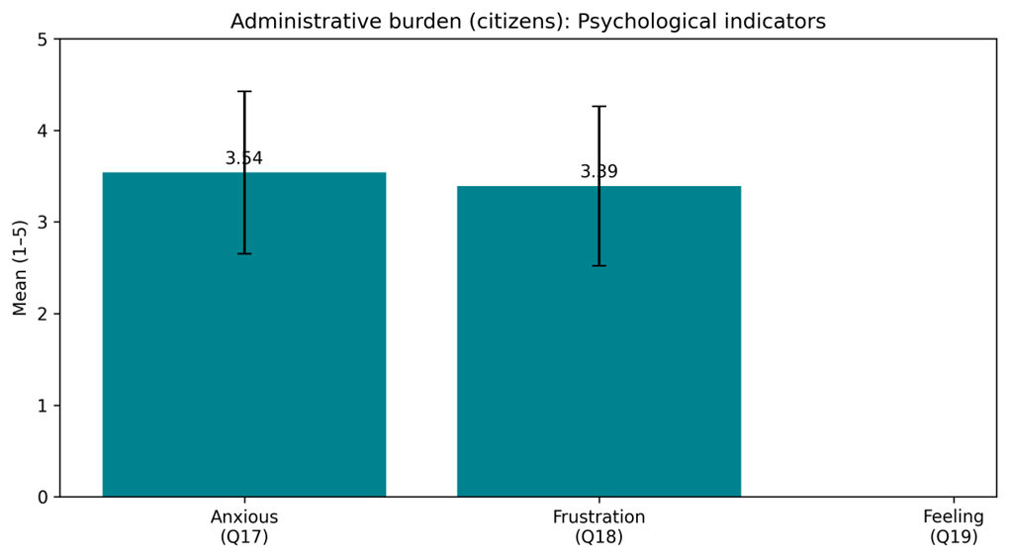
Figure 13. Psychological cost indicators (citizens): Means ± SD.

Table 4.11: Officials’ View of Psychological Stress Factors (N = 13)
Indicator | Mean | SD | N
Citizens feel stressed/anxious about making mistakes (Item 11) | 2.69 | 0.75 | 13
Citizens become frustrated when the system is complex or slow (Item 12) | 3.23 | 0.73 | 13

4.5.4 Summary of administrative burden results
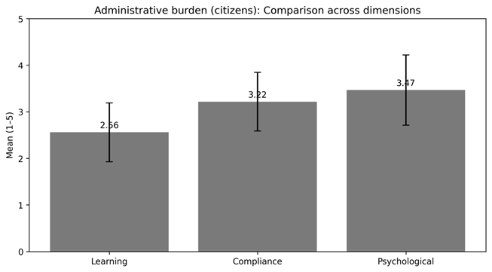
Hathazari Upazila is associated with diverse patterns of burden reduction across dimensions.Learning costs are quite modest (M = 2.56), indicating that many respondents can complete the fundamental procedures without requiring large time investment—though officials continue to detect significant gaps in citizens' digital abilities and the need for advice. Compliance costs remain substantially greater (M = 3.22), reflecting lengthy waiting time, documentation demands, and additional costs, which authorities confirm through high agreement that several contacts/visits may still be required.Psychological costs are highest (M = 3.48), indicating that uncertainty and frustration—especially around system errors, complexity, and delays—continue to shape the citizen experience even when services move online.
Ranking the burden dimensions by mean score (highest to lowest) yields: Psychological costs, Compliance costs, and Learning costs.
Figure 14. Burden dimensions (citizens): Means ± SD.

4.7 Administrative Efficiency and Overall Impact
This section brings together descriptive evidence on administrative efficiency (RQ2) with formal hypothesis testing (H1–H4). Efficiency results are presented in a comparative form using citizens’ experience-based indicators and officials’ operational assessments. The hypothesis tests then examine the central quantitative model of this thesis—whether e-service quality reduces administrative burden, whether burden is associated with citizen satisfaction, and whether burden functions as a pathway through which e-service quality influences satisfaction.
4.7.1 Administrative efficiency (RQ2)
Administrative efficiency is captured here as perceived time savings, process streamlining, and overall convenience. Citizens’ indicators reflect how users experience the speed and ease of the digital process, while officials’ indicators reflect whether office processes are being simplified in practice (for example, fewer manual steps, reduced service time, and improved overall efficiency). Table 4.15 provides a side-by-side summary.
Table 4.15: Administrative Efficiency Indicators (Citizens vs Officials)
Figure 15. Citizen satisfaction items: Means ± SD.

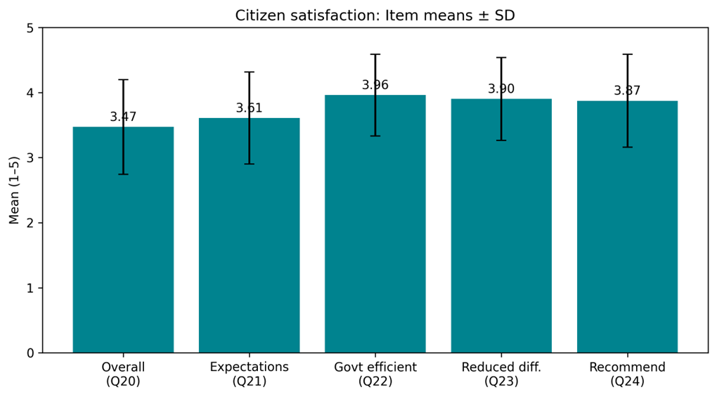
Efficiency aspect | Citizens indicator | Citizens Mean | Citizens SD | Citizens N | Officials indicator | Officials Mean | Officials SD | Officials N
Speed / time saving | Perceived efficiency gains from digitalization (Q22) | 3.96 | 0.63 | 102 | Citizen service requires less time than before (Item 9) | 4.31 | 0.48 | 13
Process streamlining | Reduced overall difficulties vs traditional service (Q23) | 3.90 | 0.64 | 102 | E-service reduces manual steps (Item 4) | 4.08 | 0.28 | 13
Convenience / usability → satisfaction | Fast & easy e-service increases satisfaction (Q25; rescaled) | 5.00 | 0.00 | 95 | Overall administrative efficiency has improved (Item 16) | 4.00 | 0.41 | 13
Note: Citizen indicators are drawn from items Q22, Q23, and Q25 (Q25 rescaled to align with a 5-point interpretation). Officials’ indicators are drawn from Items 4, 9, and 16. Higher values indicate stronger agreement with efficiency gains.

Two patterns stand out. First, citizens generally agreed that digitalization is improving government efficiency and reducing service difficulties, suggesting that the user-facing process is perceived as comparatively faster and more convenient than traditional channels. Second, officials reported strong agreement that manual steps have reduced and that overall administrative efficiency has improved, providing supply-side support for citizens’ efficiency perceptions.
Figure 16. Administrative efficiency indicators: Citizens vs Officials (Means ± SD).
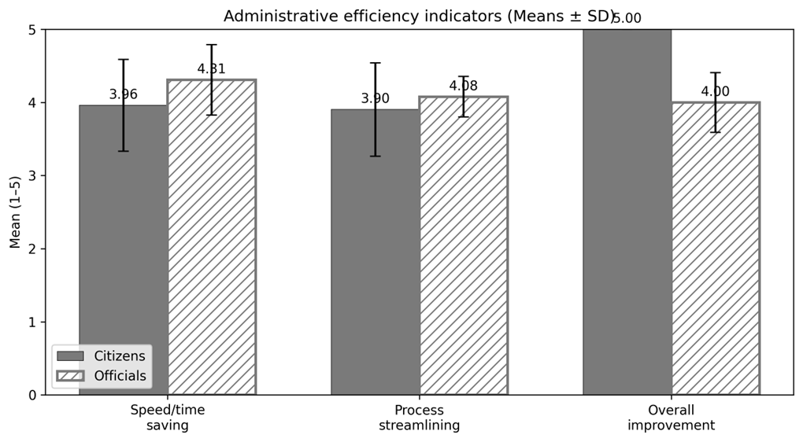

4.7.2 Hypothesis testing using regression models (H1–H3)
To test the core hypotheses, three bivariate regression models were estimated using citizen survey indices. Model A tests whether e-service quality predicts administrative burden (H1). Model B tests whether administrative burden predicts citizen satisfaction (H2). Model C tests whether e-service quality predicts citizen satisfaction (H3). Table 4.16 reports the regression summaries.
Table 4.16: Regression Results Summary (H1–H3)
Model | Dependent variable | Predictor | B | SE B | β | t | Sig. | R² | Adj. R² | F | df
Model A (H1) | Administrative burden | ESQ | -0.325 | 0.074 | -0.401 | -4.382 | < .001 | 0.161 | 0.153 | 19.203 | 1,100
Model B (H2) | Citizen satisfaction | Burden | -0.320 | 0.092 | -0.329 | -3.487 | < .001 | 0.108 | 0.100 | 12.162 | 1,100
Model C (H3) | Citizen satisfaction | ESQ | 0.491 | 0.061 | 0.625 | 7.998 | < .001 | 0.390 | 0.384 | 63.968 | 1,100
Note: B = unstandardized coefficient; β = standardized coefficient; Sig. = p-value. Analyses are based on available cases (N = 102).

Figure 17. Standardized regression effects (β and p shown).
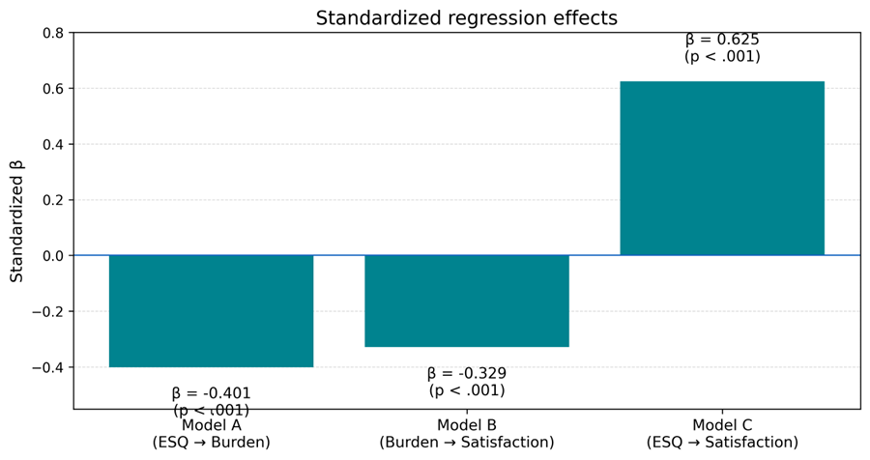

Figure 18: Model A (H1) — E-service Quality → Administrative Burden
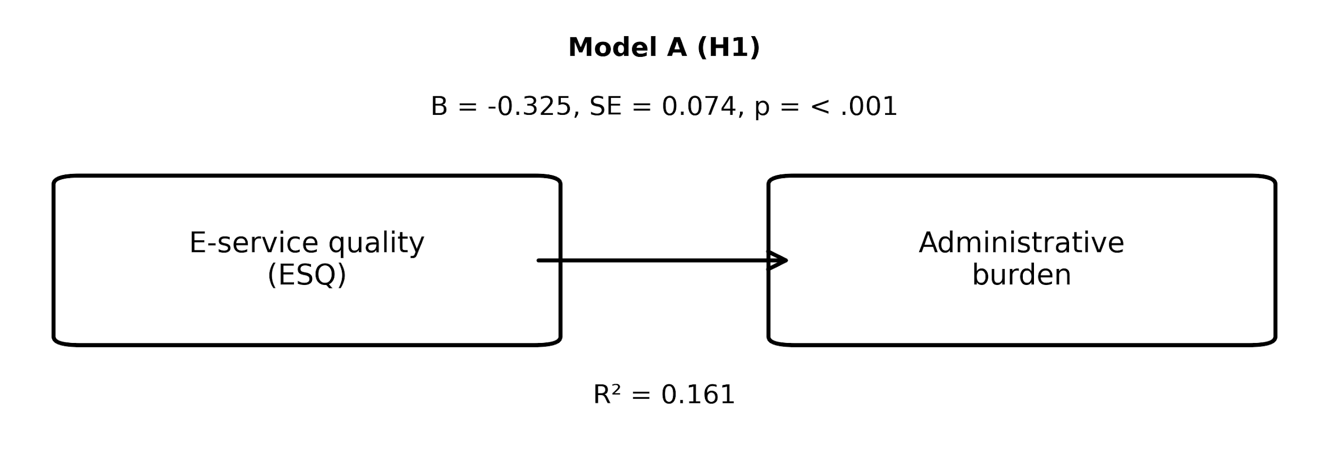
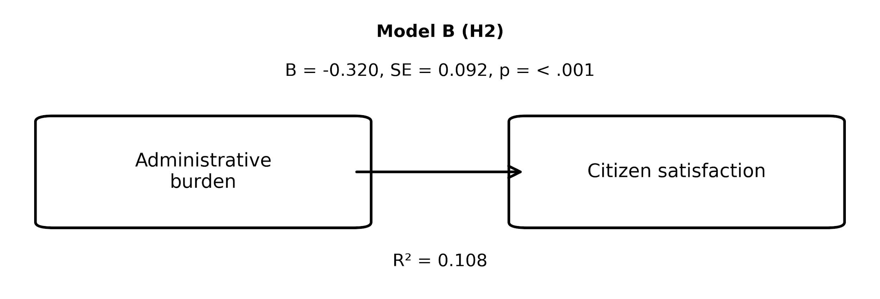
Figure 19: Model B (H2) — Administrative Burden → Citizen Satisfaction

Figure 20 : Model C (H3) — E-service Quality → Citizen Satisfaction
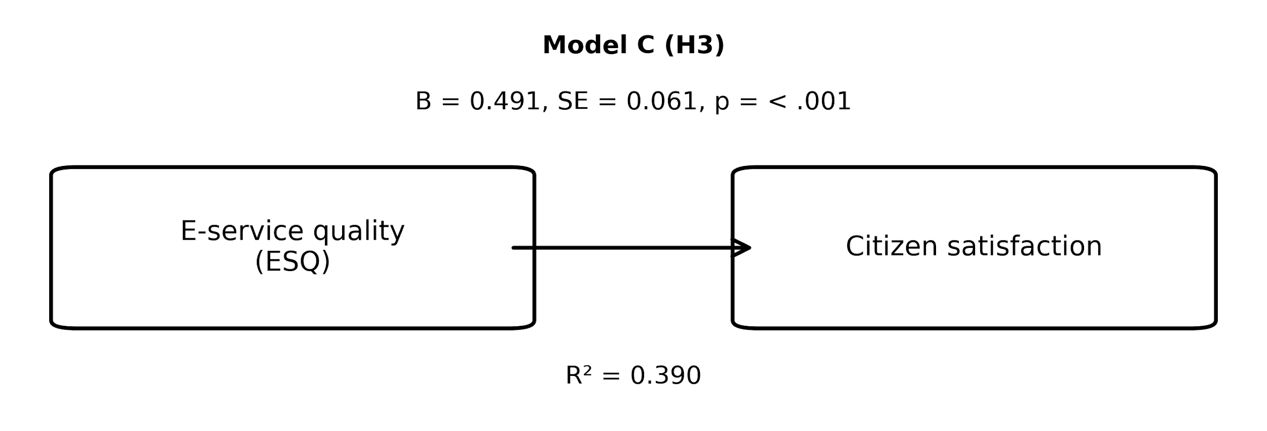4.7.3 Mediation / indirect effect (H4)
A mediation model (PROCESS Model 4 logic) was estimated to examine whether administrative burden mediates the relationship between e-service quality and citizen satisfaction (H4). The a-path captures the effect of e-service quality on burden; the b-path captures the effect of burden on satisfaction while controlling for e-service quality; the total effect (c) captures the overall effect of e-service quality on satisfaction; and the direct effect (c′) captures the remaining effect of e-service quality on satisfaction after accounting for burden. The indirect effect (a×b) was assessed using bootstrapping (5,000 resamples) to obtain a bias-free confidence interval.
Table 4.17A: Mediation Path Coefficients (Model 4)
Path | B | SE | t | Sig.
a (ESQ → Burden) | -0.325 | 0.074 | -4.382 | < .001
b (Burden → Satisfaction | ESQ) | -0.091 | 0.083 | -1.100 | .274
c (Total effect: ESQ → Satisfaction) | 0.491 | 0.061 | 7.998 | < .001
c′ (Direct effect: ESQ → Satisfaction | Burden) | 0.462 | 0.067 | 6.892 | < .001
Note: Paths are estimated using OLS regression with citizen indices. Sig. values follow conventional thresholds.
Figure 21. Indirect effect: bootstrap 95% CI.
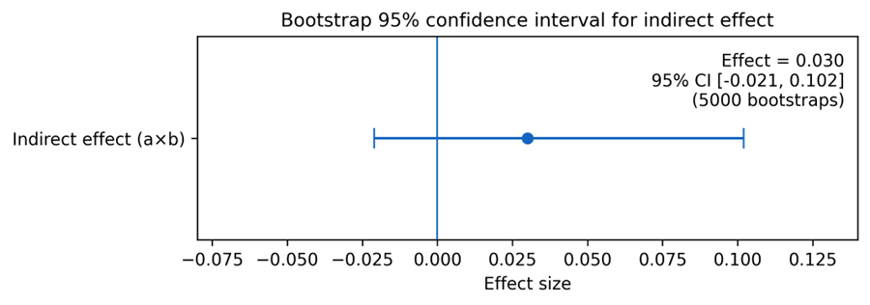

Table 22 B: Indirect Effect of ESQ on Satisfaction via Administrative Burden
Effect | B | BootLLCI (95%) | BootULCI (95%) | Bootstraps
Indirect effect (a×b) | 0.030 | -0.021 | 0.102 | 5000
Note: If the 95% bootstrap confidence interval does not include zero, the indirect effect is statistically supported.

Figure 23: Mediation model (H4) — E-service Quality → Administrative Burden → Citizen Satisfaction
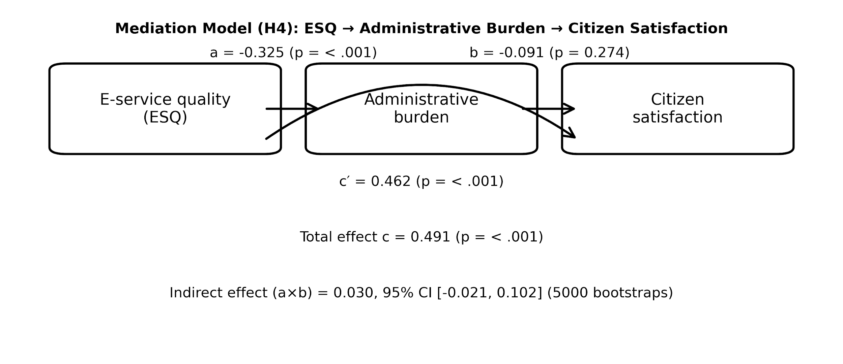
4.7.4 Integrated quantitative conclusion
Taken together, the quantitative results provide a coherent answer to the study’s research questions. First, citizens’ descriptive results indicate that administrative burden is not eliminated by digitalization, but varies across learning, compliance, and psychological costs (RQ1). Second, both citizens and officials report meaningful efficiency gains in speed and process streamlining, supporting the claim that e-services are improving administrative efficiency in Hathazari Upazila (RQ2). Third, the regression evidence shows that higher administrative burden is associated with lower citizen satisfaction (RQ3). Finally, the model results indicate that e-service quality exerts a strong positive total effect on satisfaction, while also reducing burden; however, the indirect pathway through burden is comparatively modest in magnitude and, based on the bootstrap confidence interval, does not reach a conventional level of statistical support in this sample (RQ4).
With respect to hypothesis testing, H1 was supported (ESQ significantly reduced administrative burden). H2 was supported (higher burden significantly reduced satisfaction; equivalently, reduced burden improved satisfaction). H3 was supported (ESQ significantly increased satisfaction). H4 was not supported based on the bootstrap confidence interval for the indirect effect.

CHAPTER FIVE
QUALITATIVE ANALYSIS
5.1 Introduction
This chapter explains the lived experiences behind the survey patterns reported in Chapter 4. While the quantitative models indicate how e-service quality, administrative burden, and citizen satisfaction relate statistically, the open-ended responses clarify why those relationships take the form observed in Hathazari Upazila. Accordingly, the qualitative analysis is used here as an interpretive layer—highlighting concrete difficulties, coping strategies, and practical implementation realities that sit beneath the numerical averages.
Two sources of qualitative evidence are used. First, citizens (N = 102) provided open-ended comments on meanings of “easy access to government,” difficulties experienced during e-service use, the most confusing parts of the online process, time and effort demands, the need for any physical office visits, bad experiences (technical versus administrative causes), and suggestions for improvement. Second, officials (N = 13) provided open-ended reflections on the operational state of e-service delivery (equipment, connectivity, and human resources), the most common learning and compliance barriers observed among citizens, stress triggers, perceived citizen impacts, efficiency implications, and needed system changes.
The analysis follows a thematic approach. Responses were first read repeatedly and coded at the phrase and sentence level. Coding combined a deductive lens—anchored in administrative burden theory (learning, compliance, and psychological costs)—with inductive openness to themes that emerged directly from respondents’ wording (such as network instability, office–online hybridity, or perceptions of fairness). Codes were then clustered into categories and consolidated into higher-order themes used to structure Sections 5.4–5.7.
5.2 Introduce with Respondents
5.2.1 Citizen respondents (qualitative subset)
Open-ended comments were provided by a substantial portion of the citizen sample across the qualitative items. Because the study’s purpose is interpretive rather than statistical in this chapter, the emphasis is placed on the content of accounts rather than detailed demographic breakdowns. All responses were anonymized. Quotes are attributed using an identifier and two non-identifying descriptors (gender and age group), for example: (Citizen R12, Female, 26–35).
5.2.2 Officials respondents (qualitative subset)
Officials’ open-ended responses reflect diverse institutional positions involved in e-service delivery—frontline service providers, administrative staff, and roles with ICT or coordination functions. To preserve confidentiality, quotations are anonymized using a simple label format that includes role category and years of public service experience, for example: (Official O3, Service Provider, 7–15 years).

5.3 Thematic Analysis
5.3.1 Coding strategy
Coding proceeded in two stages. In the first cycle, descriptive codes were applied to capture explicit content (e.g., “server down,” “needs guidance,” “document verification,” “office visit,” “unclear instructions”). In the second cycle, codes were interpreted and grouped into conceptual clusters aligned with the study’s conceptual framework. This approach retained the explanatory strength of administrative burden theory while avoiding forcing all statements into pre-defined boxes—allowing recurrent operational themes to remain visible.
5.3.2 Theme mapping to research questions
Themes are mapped to the research questions as follows. Themes related to learning, compliance, and psychological costs speak directly to RQ1 (the extent and character of burden reduction). Themes describing speed, process streamlining, and online–offline hybridity address RQ2 (administrative efficiency). Themes connecting hassle, stress, and perceived convenience inform RQ3 (burden–satisfaction relationship). Finally, themes explaining mechanisms—how reduced steps, reduced uncertainty, or reduced dependence on intermediaries translate into trust and satisfaction—are used to interpret RQ4.
5.4 E-service Quality and System Performance
This section synthesizes citizen and official narratives around e-service quality and system performance. Across both groups, four interlinked theme blocks emerged: (i) ease and convenience, (ii) system reliability and glitches, (iii) transparency and reduced broker influence, and (iv) backend constraints. Together, these themes help explain why citizens rated e-service quality positively overall in Chapter 4, while still reporting uneven experiences across items and circumstances.
Theme: Ease and convenience
Many citizens describe e-services as valuable primarily because they reduce the felt distance to government—saving time, reducing travel, and enabling quicker access to information or submission. These accounts are consistent with the comparatively strong quantitative ratings on clarity and transparency and with officials’ emphasis on reduced manual steps and time savings.
Selected citizen quotes:
“"Easy Access to Government" refers to citizens' rapid, direct, and hassle-free participation in government services, information, and policy-making processes through the use of technology and policies. (Citizen R1, Male, 18–25)
“Getting official government facilities within a short period of time” (Citizen R3, Female, 18–25)
“Fast service :Government Services within a short period of time” (Citizen R6, Male, 18–25)
“Fast service :Government Services within a short period of time, Govt Service received via Internet, 24/7 Availability, Affordable” (Citizen R8, Male, 18–25)
Selected official quotes:
“Yes, administrative efficiency increases compared to traditional manual paper based service delivery system” (Official O1, UNO, 7-15 years)
“it reduce time of Service Delivery” (Official O5, Secretary, 21+ years)
Interpretive link to Chapter 4: These narratives reinforce the quantitative pattern of generally positive e-service quality ratings, while clarifying why variability remains—particularly where system reliability and required offline steps constrain the promised convenience of digital delivery.
Theme: System reliability and glitches
A recurring qualification in citizens’ accounts is that convenience depends on system reliability. When connectivity is weak or platform responsiveness declines, the digital channel can quickly shift from being ‘time-saving’ to being ‘time-consuming,’ often generating repeated attempts and uncertainty. Officials’ narratives echo this dependence on stable infrastructure, particularly internet reliability and adequate equipment.
Selected citizen quotes:
“Servers remain down sometimes” (Citizen R3, Female, 18–25)
“Network problem, website down” (Citizen R10, Female, 18–25)
“Server down” (Citizen R19, Female, 36–45)
“Server Down” (Citizen R21, Male, 26–35)
Selected official quotes:
“Lack internet connectivity, and specialized software” (Official O3, Udc entrepreneur, 7-15 years)
“Lacking proper internet connections, my experience is better than manual service delivery. It reduces many steps. Skill service provider required because citizens words while one service provider providing service . Others have to wait.” (Official O4, Service Provider, 7-15 years)
Interpretive link to Chapter 4: These narratives reinforce the quantitative pattern of generally positive e-service quality ratings, while clarifying why variability remains—particularly where system reliability and required offline steps constrain the promised convenience of digital delivery.
Theme: Transparency and reduced broker influence
A smaller but meaningful set of responses frame e-service quality in moral terms—associating online procedures with clearer rules and reduced need to rely on intermediaries. Where citizens perceive that fees and requirements are clearer online, the service is interpreted as more transparent and fair, with fewer opportunities for broker-driven manipulation. Officials similarly point to improved public trust and reduced complaints where processes become more standardized.
Selected citizen quotes:
“policy/process itself was complicated (administrative), Mostly for administrative reasons, but sometimes there were technical issues too.” (Citizen R101, Male, 18–25)
“website was poorly designed (technical),, policy/process itself was complicated (administrative)” (Citizen R9, Male, 18–25)
Selected official quotes:
“Positive, confusion reduced in terms of self service and instruction” (Official O8, Secretary, 16-20 years)
“Increases a lot” (Official O4, Service Provider, 7-15 years)
Interpretive link to Chapter 4: These narratives reinforce the quantitative pattern of generally positive e-service quality ratings, while clarifying why variability remains—particularly where system reliability and required offline steps constrain the promised convenience of digital delivery.
Theme: Backend constraints
Citizens’ comments also reveal the persistence of ‘hybrid’ service delivery. Even after initiating services online, many respondents still describe the need for office visits for verification, document checks, or completion steps. Officials’ responses help explain this persistence by pointing to staffing, training needs, equipment constraints, and rule-bound verification requirements—factors that keep some steps anchored in the physical office.
Selected citizen quotes:
“Yes,for certain reasons. Collection of my final document” (Citizen R21, Male, 26–35)
“Yes,for document Collection” (Citizen R28, Male, 36–45)
“Yes,for biometric” (Citizen R56, Female, 36–45)
“Yes,because I thought it would be easier to get the service from Union office” (Citizen R58, Male, 46–60)
Selected official quotes:
“Training of officials and and if I want to say something or recommend something to citizens that is to lower their expectations, I'm not saying that to compare to traditionals service delivery. But not keep the expectation so high” (Official O2, Administrative Officials, 21+ years)
“training” (Official O6, Administrative Officials, 16-20 years)
Interpretive link to Chapter 4: These narratives reinforce the quantitative pattern of generally positive e-service quality ratings, while clarifying why variability remains—particularly where system reliability and required offline steps constrain the promised convenience of digital delivery.

5.5 Administrative Burden
The open-ended narratives help clarify why administrative burden persists even when the service channel becomes digital. Citizens’ comments provide first-hand evidence of the points at which learning, compliance, and psychological costs are generated; officials’ accounts explain how these costs are reproduced by capacity limits, verification rules, and infrastructure constraints. The themes below are presented as an interpretive companion to the burden indices reported in Chapter 4.
5.5.1 Learning costs
Two learning-related patterns recur strongly: (i) respondents who experienced clear instructions and a familiar interface report that the process is straightforward, but (ii) many others describe digital literacy barriers—especially around understanding steps, language, form fields, and login/OTP procedures. Where these barriers are present, citizens often rely on informal assistance from family members, cyber cafés, or ‘someone who knows how to do it,’ which effectively shifts learning costs onto social networks and paid intermediaries.
Illustrative citizen accounts (instructions vs digital literacy barriers):
“Deciphering legal jargon in Terms of Service (ToS) and Privacy Policies. Understanding data sharing: Not knowing exactly what data is being collected or with whom it is being shared.” (Citizen R71, Male, 18–25)
“Online itself is an easy process. But the difficulty is when I need to go to the office with the online copies” (Citizen R3, Female, 18–25)
“Sometimes the server doesn't work properly and there is no smart way to find information.” (Citizen R12, Female, 26–35)
“Since I haven't used it, I don't have a good answer for this.” (Citizen R20, Male, 26–35)
Citizen accounts indicating informal help dependence (family/cyber café/agents):
“1. Servers were slow and sometimes unaccessible under gravy traffic. 2. The UIs were sometimes not very user friendly” (Citizen R101, Male, 18–25)
“server breakdown,frequently need to fillup the information whenever it needs to reconnect .” (Citizen R86, Female, 26–35)
“"Network slowness and insufficient information to reach the site” (Citizen R52, Female, 18–25)
Officials largely confirm this pattern. They commonly describe citizen difficulty with understanding steps and repeatedly needing explanation, and several explicitly argue for structured support mechanisms—guidance desks, more user-friendly forms, and practical training or orientation.
Selected official reflections (why learning burdens persist):
“They lack digital skills, mainly understanding. The language and instruction” (Official O1, UNO, 7-15 years)
“understanding steps” (Official O2, Administrative Officials, 21+ years)
Officials’ suggested improvements (guidance, training, simplified forms):
“Training of officials and and if I want to say something or recommend something to citizens that is to lower their expectations, I'm not saying that to compare to traditionals service delivery. But not keep the expectation so high” (Official O2, Administrative Officials, 21+ years)
“What can be changed is limited by the law. So if I want to change. I can't due the law bined me” (Official O1, UNO, 7-15 years)
5.5.2 Compliance costs
Citizens’ open-ended responses indicate that compliance costs are reduced in some respects—especially where travel and repeated physical presence decline—but are not eliminated. A common experience is the continuation of ‘verification visits’ even after online initiation. Respondents also describe document complexity (collecting, scanning, uploading, and correcting paperwork), and delays driven by waiting, repeated submissions, or incomplete processing.
Citizen accounts of reduced travel but persistent verification visits:
“Yes, for hardcopy” (Citizen R44, Female, 36–45)
“Yes,for biometric” (Citizen R56, Female, 36–45)
“Yes,because I thought it would be easier to get the service from Union office” (Citizen R58, Male, 46–60)
“Yes, but because physical presence was absolutely essential.” (Citizen R70, Male, 18–25)
Citizen accounts highlighting document complexity and procedural requirements:
“1. Servers were slow and sometimes unaccessible under gravy traffic. 2. The UIs were sometimes not very user friendly” (Citizen R101, Male, 18–25)
“server breakdown frequently needs to fill up the information whenever it needs to reconnect .” (Citizen R86, Female, 26–35)
“Slow network and insufficient information to browse through the site” (Citizen R52, Female, 18–25)
Citizen accounts describing waiting time or repeated submission attempts:
“Regular. Not much delay” (Citizen R9, Male, 18–25)
“An hour and a half. Depends on the type of work. This is how long it took to process my driving license.” (Citizen R70, Male, 18–25)
“Online service takes less time, but going to the office to get service takes a long time.” (Citizen R90, Female, 18–25)
Officials’ accounts provide the institutional logic behind these compliance burdens. They point to rule-bound checks, document verification requirements, and coordination frictions across offices or units—factors that keep parts of the process ‘sticky’ and difficult to fully digitize.
Selected official reflections (policy rules, checks, coordination bottlenecks):
“visits it remains the same but considerably a little less” (Official O1, UNO, 7-15 years)
“Visit remains the same as and procedure became easier” (Official O3, Udc entrepreneur, 7-15 years)
5.5.3 Psychological costs
Psychological costs appear in two contrasting forms. For some citizens, digital processes create relief—particularly where they perceive fewer opportunities for harassment or arbitrary demands. For others, anxiety emerges from uncertainty: fear of making mistakes, concern that an error will ‘block’ the process, and frustration when systems are slow or unresponsive. This anxiety is amplified in moments of downtime or network instability, when citizens cannot easily predict what will happen next or how long the delay will last.
Citizen accounts of anxiety and frustration due to errors, delays, or system problems:
“policy/process itself was complicated (administrative), mostly for administrative reasons, but sometimes there were technical issues too.” (Citizen R101, Male, 18–25)
“website was poorly designed (technical),, policy/process itself was complicated (administrative)” (Citizen R9, Male, 18–25)
Citizen accounts reflecting relief linked to fairness/transparency (where present):
“policy/process itself was complicated (administrative), Mostly for administrative reasons, but sometimes there were technical issues too.” (Citizen R101, Male, 18–25)
“website was poorly designed (technical),, policy/process itself was complicated (administrative)” (Citizen R9, Male, 18–25)
Officials similarly observe that frustration peaks when the system is slow, the network is down, or users become uncertain about whether a submission has been accepted. In this sense, the psychological cost is not only an individual feeling, but also a predictable consequence of infrastructure fragility and unclear feedback mechanisms in the service process.
Selected official reflections (stress triggers: slow systems, network downtime):
“It increases stress as the service is available 24/7. So on the other hand, citizen have access over it all the time there stress reduced” (Official O1, UNO, 7-15 years)
“After everything become online is reduced stress in many ways” (Official O2, Administrative Officials, 21+ years)
Synthesis link to Chapter 4: The qualitative evidence aligns closely with the quantitative burden profile. Learning burdens were comparatively lower on average (M = 2.56, SD = 0.63), but persist where digital literacy is uneven and support is informal. Compliance burdens remain moderate (M = 3.22, SD = 0.63) because verification visits and document-heavy requirements continue. Psychological burdens were the highest of the three (M = 3.48, SD = 0.78), and respondents’ narratives locate this stress precisely in uncertainty, errors, and system downtime. Overall burden remains present (M = 3.08, SD = 0.50), reinforcing the conclusion that e-services reduce—but do not remove—administrative hassle.

5.6 Citizen Satisfaction
Citizens’ satisfaction narratives are strongly grounded in practical benefits rather than abstract approval. Across responses, satisfaction is repeatedly framed as (i) time saved, (ii) less hassle, and (iii) perceptions of fairness or transparency—especially where rules and fees are clearer and dependence on intermediaries is reduced. Officials reinforce these points by describing reduced complaints, improved acceptance of digital channels, and the belief that citizens value faster service and simpler steps most.
Theme: “Time saved” satisfaction
“Online did not take much time. But offline took 3-5 working days” (Citizen R3, Female, 18–25)
“not much time” (Citizen R12, Female, 26–35)
“it took considerable time” (Citizen R25, Female, 18–25)
Official triangulation (observed impacts on citizens):
“Positive, confusion reduced in terms of self service and instruction” (Official O8, Secretary, 16-20 years)
“Increases a lot” (Official O4, Service Provider, 7-15 years)
Theme: “Less hassle” satisfaction
“1. Servers were slow and sometimes unaccessible under gravy traffic. 2. The UIs were sometimes not very user friendly” (Citizen R101, Male, 18–25)
“server breakdown,frequently need to fillup the information whenever it needs to reconnect .” (Citizen R86, Female, 26–35)
Theme: “Fairness/transparency” satisfaction
“policy/process itself was complicated (administrative), mostly for administrative reasons, but sometimes there were technical issues too.” (Citizen R101, Male, 18–25)
“website was poorly designed (technical),, policy/process itself was complicated (administrative)” (Citizen R9, Male, 18–25)
Tie to RQ3 and RQ4: These themes clarify why administrative burden and satisfaction move together. When citizens describe satisfaction, they are often describing the absence of administrative burden: fewer steps, fewer trips, less uncertainty, and fewer opportunities for arbitrary demands. In other words, reduced burden functions as a mechanism that converts e-service quality into satisfaction—especially through saved time and reduced procedural stress.

5.7 Administrative Efficiency and Overall Impact
The qualitative evidence converges on a balanced conclusion: e-service delivery has improved administrative efficiency and citizen experience, but it operates within institutional constraints that prevent full burden elimination. Respondents repeatedly describe faster processing and fewer steps when the system works well, alongside bottlenecks created by internet instability, limited equipment, staff capacity, and verification rules.
Theme: Faster processing and fewer steps
Citizens’ one-word summaries often capture speed/convenience (and, at times, the opposite when the system fails):
“My experience was good because most of the time I use government services and the officials are very active in providing digital services.” (Citizen R3, Female, 18–25)
“Slow” (Citizen R5, Male, 26–35)
“Helpful and easy to use.” (Citizen R11, Female, 26–35)
“Helpful and easy to use” (Citizen R13, Male, 18–25)
Officials’ reflections on efficiency and workload/process change:
“Yes, administrative efficiency increases compared to traditional manual paper based service delivery system” (Official O1, UNO, 7-15 years)
“it reduce time of Service Delivery” (Official O5, Secretary, 21+ years)
Theme: Better coordination (or lack of it)
Several accounts point to coordination gaps—where progress depends on multiple checks, approvals, or unit-to-unit verification that may not be fully integrated digitally. In such cases, the citizen experiences the e-service as ‘started online but completed offline,’ which partially reduces burden but also introduces new uncertainty about responsibilities and timelines.
Theme: Institutional constraints (staffing, infrastructure, internet)
Officials’ descriptions of system performance constraints:
“Lack of skill personnel” (Official O2, Administrative Officials, 21+ years)
“Lack internet connectivity, and specialized software” (Official O3, Udc entrepreneur, 7-15 years)
Officials’ recommended changes (infrastructure, staffing, training, system upgrades):
“Training of officials and and if I want to say something or recommend something to citizens that is to lower their expectations, I'm not saying that to compare to traditionals service delivery. But not keep the expectation so high” (Official O2, Administrative Officials, 21+ years)
“Well established and dedicated, properly designed software in my union office” (Official O7, Secretary, 16-20 years)
Citizens’ improvement suggestions (what they want fixed first):
“Network available” (Citizen R8, Male, 18–25)
“Improve Server Stability and easy to navigate page, Digital Campaign for e-service” (Citizen R10, Female, 18–25)
“Improve server stability and easy to navigate” (Citizen R12, Female, 26–35)
Qualitative wrap-up: what these results add beyond the numbers
First, the qualitative evidence shows that ‘ease’ is conditional: the same digital service can feel efficient for digitally confident users and burdensome for others. Second, it reveals that administrative burden often shifts form rather than disappearing—moving from travel and queuing to documentation management, login/OTP problems, and uncertainty about submission status. Third, it identifies system reliability as a central hinge variable: network downtime and platform glitches convert convenience into frustration very quickly.
Fourth, it demonstrates why satisfaction may remain comparatively elevated despite ongoing burdens—because citizens place significant emphasis on time savings and diminished inconvenience in their overall judgement. Fifth, officials attribute the ongoing verification processes and coordination delays to adherence to regulations and limitations in capability, rather than solely to 'user mistake.’ Finally , triangulation reveals the entire impact: e-service delivery significantly enhances access and efficiency in Hathazari Upazila;nevertheless, more advancements rely on infrastructure stability, user support, and process redesigning rather than solely on digitalization.

CHAPTER SIX
DISCUSSION AND CONCLUSION
6.1 Introduction
This chapter discusses what the findings mean for local digital service delivery in Hathazari Upazila. It does not restate results; rather, it interprets the patterns, links them back to the study objectives, and answers the research questions in a way that can stand as the final thesis claim. The discussion intentionally integrates two sources of evidence: citizens’ responses (n = 102), which provide the primary test of relationships among e-service quality, administrative burden, efficiency and satisfaction; and officials’ responses (n = 13), which provide the implementation-side explanation for why particular burdens persist and why improvements are uneven across users.
The chapter proceeds in four steps. Section 6.2 tests hypotheses H1–H4 by combining the quantitative results with qualitative triangulation. Section 6.3 synthesizes the findings against the two specific objectives. Section 6.4 highlights the conceptual/analytical implications for administrative burden and digital government research. Section 6.5 concludes by presenting clear, direct answers to the four research questions.

6.2 Test of Research Hypothesis (H1–H4)
Hypothesis testing is presented as an integrated judgement rather than a purely statistical checklist. Accordingly, Table 6.1 reports the quantitative outcomes from Chapter 4, and then indicates how the qualitative evidence from Chapter 5 supports, clarifies, or qualifies each relationship in the Hathazari service context.
Table 6.1: Hypothesis Testing Summary
Hypothesis | Relationship tested | Quantitative evidence (Chapter 4) | Qualitative triangulation (Chapter 5) | Decision
H1 | ESQ → Burden (negative) | B = -0.325, SE = 0.074, p = 2.9e-05, R² = 0.161 | Citizens describe smoother completion when the system is clear/available; officials emphasize uneven digital literacy and the need for structured guidance. | Supported
H2 | Reduced burden → Satisfaction (positive) | B = -0.320, SE = 0.092, p = 0.000726, R² = 0.108 | Satisfaction is framed as time saved/less hassle; burden persists via verification visits, document complexity, and stress during downtime. | Supported
H3 | ESQ → Satisfaction (positive) | B = 0.491, SE = 0.061, p = 2.3e-12, R² = 0.390 | Citizens value clarity/reliability; officials report greater acceptance and fewer complaints where systems are stable. | Supported
H4 | ESQ → Burden → Satisfaction (mediation) | a×b = 0.030, 95% CI [-0.021, 0.102] (5000 bootstraps); b-path p = 0.274 | Narratives indicate a burden-reduction mechanism, but implementation constraints make the pathway uneven across users. | Not supported (CI crosses zero)

Hypothesis 1: Effect of E-Service Delivery on Administrative Burden
Null Hypothesis (H01): E-service delivery has no significant effect on administrative burden.
Alternative Hypothesis (H1): E-service delivery has a significant negative effect on administrative burden.
The statistical result supports H1: e-service quality is associated with lower administrative burden (B = -0.325, p = 2.9e-05; R² = 0.161). In practical terms, the better the platform performs—particularly in availability, clarity of instructions, and ease of locating services—the less ‘work’ citizens report having to do to complete the process.
The qualitative material explains why this relationship holds. Citizens describe the digital service as genuinely convenient when the system is stable and guidance is clear; however, they also report that burden returns quickly when steps are unclear, when they are unsure about requirements, or when technical interruptions occur. Officials confirm this unevenness by describing recurring citizen difficulty with understanding steps and the repeated need for support, implying that service quality improvements must include user-facing guidance and not only technical upgrades.

Hypothesis 2: Effect of Reduced Administrative Burden on Citizen Satisfaction
Null Hypothesis (H02):Reduced administrative burden has no significant effect on citizen satisfaction.
Alternative Hypothesis (H2):Reduced administrative burden has a significant positive effect on citizen satisfaction.
H2 is also supported statistically (B = -0.320, p = 0.000726; R² = 0.108). Given the burden index direction used in this thesis, the implication is straightforward: satisfaction improves as learning, compliance, and psychological costs decline.
Qualitative evidence makes the burden–satisfaction link almost intuitive. Citizens most often describe satisfaction through concrete reductions in hassle—time saved, fewer trips, and greater predictability. In contrast, when compliance requirements remain document-heavy or verification visits are still required, citizens report dissatisfaction and tiredness, which directly impact happiness. Official sources agree with this interpretation, particularly about how delays, slow systems, and network issues cause citizen frustration and complaints.

Hypothesis 3: Effect of E-Service Delivery on Citizen Satisfaction
Null Hypothesis (H03):E-service delivery has no significant effect on citizen satisfaction.
Alternative Hypothesis (H3): E-service delivery has a significant positive effect on citizen satisfaction.
H3 is strongly supported (B = 0.491, p = 2.3e-12; R² = 0.390). This indicates that citizens evaluate digital government not only by whether they obtain the service, but also by how the service feels to use—clarity, reliability, accessibility, and perceived security.
The qualitative findings clarify the content of ‘quality’ in this setting. Citizens interpret good performance as faster completion and reduced hassle, but they also interpret it as fairness and transparency—especially where steps and fees are clear and there is less perceived dependence on intermediaries. Officials add a supply-side mirror: where systems are stable and staff capacity is adequate, they perceive improved acceptance and reduced complaint pressure. Where equipment and internet are weak, the credibility of the service deteriorates quickly from the citizen’s viewpoint.

Hypothesis 4: Mediation Effect of Administrative Burden
Null Hypothesis (H04):Reduced administrative burden does not mediate the relationship between e-service delivery and citizen satisfaction.
Alternative Hypothesis (H4): Reduced administrative burden mediates the relationship between e-service delivery and citizen satisfaction, such that e-service delivery increases citizen satisfaction through reducing administrative burden.
The mediation test yields a balanced conclusion. The estimated indirect effect is small and statistically uncertain (a×b = 0.030, 95% CI [-0.021, 0.102]), and the b-path is not significant (p = 0.274). Because the confidence interval crosses zero, H4 is not supported in a strict statistical sense in this sample, even though the direct effect of ESQ on satisfaction remains strong.
At the same time, the qualitative evidence clearly shows a burden-based mechanism in everyday reasoning: citizens frequently justify satisfaction through reduced hassle, fewer steps, and lower stress. The most plausible interpretation for Hathazari is that burden reduction operates as a practical pathway for many users, but not consistently enough—given hybrid verification requirements, uneven digital literacy, and infrastructure instability—to emerge as a stable statistical mediator across the whole sample. In other words, the mechanism is visible in lived experience, but it is uneven and bounded by implementation realities.

6.3 Analysis Based on Research Objectives
6.3.1 Objective 1: How e-service reduces administrative burden (learning, compliance, psychological)
Across the three burden dimensions, the combined evidence supports a clear but qualified conclusion: e-service delivery reduces several citizen costs, yet it does not remove administrative burden entirely. Quantitatively, learning burden was comparatively lower (M = 2.56, SD = 0.63), suggesting that many citizens can understand and navigate the process—particularly when instructions and steps are clear. Compliance burden remains moderate (M = 3.22, SD = 0.63), reflecting continuing documentation demands, waiting time, and follow-up contacts. Psychological burden is substantial (M = 3.09, SD = 0.93), indicating that stress and uncertainty remain prominent in digital service encounters.
Qualitative narratives explain why. Learning costs are reduced for digitally confident users, but rise for those who struggle with language, form fields, and step-by-step procedures—often shifting the learning burden onto family members or paid helpers. Compliance costs are reduced mainly through easier initiation and (sometimes) fewer trips, but citizens still describe verification visits and document complexity, which keeps the process ‘hybrid’ rather than fully digital. Psychological costs intensify when citizens fear system errors, cannot predict timelines, or experience downtime; officials confirm that frustration peaks during slow systems and unstable internet. Taken together, officials’ accounts suggest the persistence of burden is not merely a user-side problem: verification rules, infrastructure limits, and staffing/training constraints keep some burdens structurally embedded.
6.3.2 Objective 2: Whether burden reduction shapes the ESQ–satisfaction relationship
The quantitative results show that e-service quality improves citizen satisfaction strongly and directly, while the mediation pathway through administrative burden is not statistically robust in this dataset. This does not mean burden is irrelevant; it suggests that the burden pathway is not equally strong for all citizens under current implementation conditions.
From the qualitative evidence, citizens’ satisfaction logic is often mechanism-based: they feel satisfied when quality reduces hassle, time loss, and stress. However, persistent verification requirements, documentation complexity, and platform instability keep burden reduction uneven. Officials’ data is critical here because it identifies the conditions under which burden reduction becomes reliable—stable internet, adequate equipment, staff capability, and process simplification. Thus, in Hathazari, burden reduction appears to be a practical pathway, but one that depends on implementation capacity and end-to-end process redesign rather than digitization alone.

6.4 Conceptual Implications
This study offers three conceptual implications that strengthen its contribution beyond local description.
Implication 1: Administrative burden theory travels well into the local e-service setting. The learning, compliance, and psychological categories align with how citizens actually describe service encounters, and the burden indices meaningfully capture systematic variation in those experiences.
Implication 2: E-service quality influences satisfaction through both direct experience and an implicit burden mechanism. The strong ESQ → satisfaction relationship demonstrates that citizens evaluate the digital state through usability, clarity, and reliability. At the same time, qualitative accounts show that citizens interpret ‘quality’ largely through reduced hassle and reduced stress—i.e., a burden-based mechanism—even when statistical mediation is weak.
Implication 3: Supply-side constraints explain why some burdens persist. Officials’ responses consistently point to infrastructure limits (internet/equipment), staffing and training gaps, and verification rules that keep some steps offline or repetitive. Analytically, this reinforces that burden reduction is co-produced: it depends on institutional design and frontline capacity, not only on the presence of a digital interface.

6.5 Conclusion
The integrated evidence allows the thesis to answer the research questions directly.
RQ1: E-service delivery reduces administrative burden most clearly by lowering some learning and travel-related compliance demands, but burden persists. Compliance burden remain where paperwork, verification visits, and waiting time persist; psychological burdens stay high when uncertainty and system instability exist.
RQ2: The faster we begin, the less bureaucratic handling is needed. And so on.As can be seen from both sides of the fence, we made convenience improvements of:Yet these gains are hedged in by institutional barriers, internet speed and prudence and staffing/training negatively effect how well we fulfil our roles. A second set of constraints is that the hybrid verification process I previously described is still not fully on line today for one reason or another. RQ3: Administrative burden and citizen satisfaction are closely related. Satisfaction increases when there is less difficulty and more regularity; it declines if citizens undergo repeated submissions, delays and illiteracy, voids of education.
RQ4: E-service quality increases satisfaction strongly. Statistically, burden does not act as a consistent mediator in this sample; however, qualitative evidence demonstrates a clear mechanism in practice—reduced burden translates into satisfaction for many users, but uneven implementation keeps this pathway from becoming uniform.
Overall, the final claim is measured but firm: e-service delivery in Hathazari Upazila is improving citizen experience and perceived efficiency, yet administrative burden remains in hybrid procedures and in the psychological strain created by unreliable systems. Further burden reduction requires infrastructure stability, user support, and end-to-end simplification—not digitization alone.

6.6 Recommendations
The recommendations below are derived directly from the integrated findings of this thesis. Quantitatively, e-service quality is strongly associated with citizen satisfaction and inversely associated with administrative burden, while burden remains most visible in compliance-related requirements and psychological strain. Qualitatively, citizens and officials converge on recurring bottlenecks—uneven digital literacy, continued verification visits, document complexity, and frustration triggered by system downtime and unclear process feedback. For that reason, recommendations are organized at two levels: immediate administrative actions at the Upazila level and broader system/policy interventions.
6.6.1 Administrative recommendations (Upazila level)
These measures can be initiated through local administrative management and service-centre practice. They are designed to reduce learning and psychological burdens for citizens while improving the day-to-day usability of e-services.
1. Establish a visible help desk / assisted digital support point at service locations (and at Union Digital Centres where relevant) to support citizens who struggle with online steps. This recommendation follows from officials’ observation that many citizens lack digital skills and require repeated explanation, and from citizens’ reliance on informal assistance.
2. Simplify forms and instructions using Bangla, visual cues (e.g., screenshots or short checklists) and step-by-step guidance so that citizens can complete tasks without repeated clarification. This directly addresses learning barriers. Also the confusion about website steps reported by citizens.
3. Reduce repeat document demands where feasible by introducing clear ‘one-time submission’ practices for commonly required documents (where policy permits) and ensuring staff apply requirements consistently. This responds to citizens’ compliance burdens linked to repeated submission and document complexity
4. Establish a structured feedback and complaint system (help counter logbook, hotline, or quick digital form) and make response times public. There were fewer complaints about the service after the use of e-services, and a structured system records unresolved complaints and prevents the buildup of frustration.
5.Enhance tracking and SMS notifications (application received, verification needed, approved/processed, next step) to alleviate uncertainty and psychological stress associated with waiting times. This addresses public dissatisfaction with uncertain progress and worries about application failure.

6.6.2 System / policy level recommendations
The following measures require coordination beyond a single office, but they address the structural constraints repeatedly raised by both citizens and officials—particularly reliability, process integration, and standardization.
1. Facilitate better backend integration between different offices so that verification and approvals do not need to be repeated citizen-level visits or manual cross-checking. It speaks to lingering hybrid finish routes and officials’ focus on procedural/coordination chokeholds.
2. Boost the reliability of the network and supply power back-up at service points in order to decrease delays and stress due to downtime. Narratives of citizens and assessments of officials are in agreement about the relationship between unstable connectivity, frustration and service discontinuation.
3. Institutionalize regular training and refresher sessions for officials and frontline staff focused on troubleshooting common platform problems and communicating requirements clearly to citizens. This is tied to the observed need for repeated explanations and the continuing dependence on staff support.
4. Standardize service requirements and publish clear service charters (documents required, fees, expected processing time, and redress channels) to improve predictability and perceived fairness. This advice is founded on the finding that satisfaction and transparency also go hand-in-hand for citizens in a democracy, and on humanity’s appreciation of reduced hassle and clearer rules.

6.7 Limitations of the Study
A number of limitations need to be considered when interpreting the findings and for informing future work on local digital government service delivery.
1. Composition of the Sample Of Citizens: The citizen sample is likely to be biased towards younger and student respondents, which could lead to an over-representation in digitally confident users and under-representation from experiences with older or more digitally excluded groups.
2. Officials sample Size: The officials’ sample (n = 13) is too small to be representative, but it’s a useful institutional triangulation source as introduced to enrich the implementation constraints.
3. Self-report perception: In both data sets, information is based on perceivers perceptions which could be prone to recall error, expectation bias or short term experiences. Nevertheless, perceptions are central to administrative burden and satisfaction as lived administrative realities.
4. Cross-sectional Design: The data were collected at a single point in time, so the relationships observed should be interpreted as associations rather than definitive causal effects.
5. Time and Resource Constraints: Due to limitations in time and available resources, the study could not incorporate more extensive samples, which might have provided deeper insights.
6. Geographic scope: The study focuses on Hathazari Upazila; findings may not generalize automatically to other Upazilas with different infrastructure conditions, administrative capacity, or service mixes.

________________________________________________________________

